**ACD_BDDOF_Session_6_Assignment_3_Main**

**Problem Statement:**

1. Write a program to read a text file and print the number of rows of data in the document.

2. Write a program to read a text file and print the number of words in the document.

3. We have a document where the word separator is -, instead of space.

Write a spark code, to obtain the count of the total number of words present in the document.

**Input file for Problem statement - 1 & 2:**

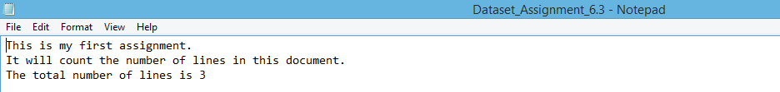

**Scala code: - 1.Row count: -**

1. Write a program to read a text file and print the number of rows of data in the document.

* Set up Spark context with application name that runs locally using all available cores
* Defined log level to display **ERROR’s** in console while executing the program

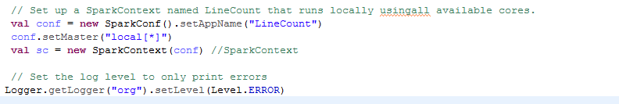

* Created an RDD called “input”using SparkContext by reading lines from input line
* flatMap() is to split each input string into words. flatMap take a line from input RDD and apply a function on that line.



* This case flatmap takes a line and splits it based on “\n” to get the count of line in doc

And used **countByValue()** to capture how many times each element occur in RDD.

* And using for loop displayed word and count of occurrence
* Stop the Spark context



**Output:**

Displayed the number of rows “3” and occurrence of lines as well.

Displays the line occurrence as – line -> occurrence.



**Scala code:- 2.Word count:**

2. Write a program to read a text file and print the number of words in the document.

* Set up Spark context with application name that runs locally using all available cores
* Defined log level to display **ERROR’s** in console while executing the program



* Created an RDD called “input”using SparkContext by reading lines from input line



* flatMap() is to split each input string into words. flatMap take a line from input RDD and apply a function on that line.In this case flatmap takes a line and splits it based on “ ” to get the count of words in doc

And used **countByValue()** to capture how many times each element occur in RDD.

* And using for loop displayed word and count of occurrence
* Stop the Spark context





**Output:**

Displayed the count of words as “22” and occurrence of words as well.

Displays the occurrence of words in file as – word -> occurrence of words in file



**Input file for Problem statement - 3:**

Input file is “-“ separated.

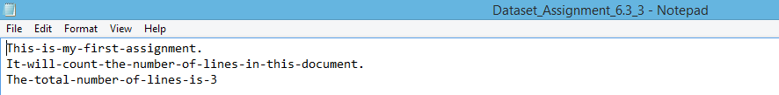

**Scala code: - Word count with delimiter”-“:**

3. We have a document where the word separator is -, instead of space.

Write a spark code, to obtain the count of the total number of words present in the document.

* Set up Spark context with application name that runs locally using all available cores
* Defined log level to display **ERROR’s** in console while executing the program



* Created an RDD called “input”using SparkContext by reading lines from input line
* flatMap() is to split each input string into words. flatMap take a line from input RDD and apply a function on that line.In this case flatmap takes a line and splits it based on “-” to get the count of words in doc



And used **countByValue()** to capture how many times each element occur in RDD.

* And using for loop displayed word and count of occurrence
* Stop the Spark context



**Output:**

Displayed the count of words as “22” and occurrence of words as well.Displays the occurrence of words in file as – word -> occurrence of words in file

